Kings Mountain

Transportation Committee

Thursday, February 6, 2025 | 4:00 PM

Kings Mountain Public Works Conf. Room

1013 N Piedmont Ave, Kings Mountain, NC

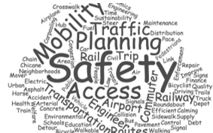

Agenda
- Call To Order
- Approvals
  - Agenda
  - Minutes from previous meeting.

- Public Comment
  - Floor open for public comment:
  - Comments from Social Media/Email, review and discussion.

- Old Business
A. Discussion items with NCDOT

V. New Business
A. Stop Signs at W Mountain and S Watterson.
B. Hendricks Street

VI. Open Committee Discussion:

VII. Adjournment

